

**1. Color the fruits**

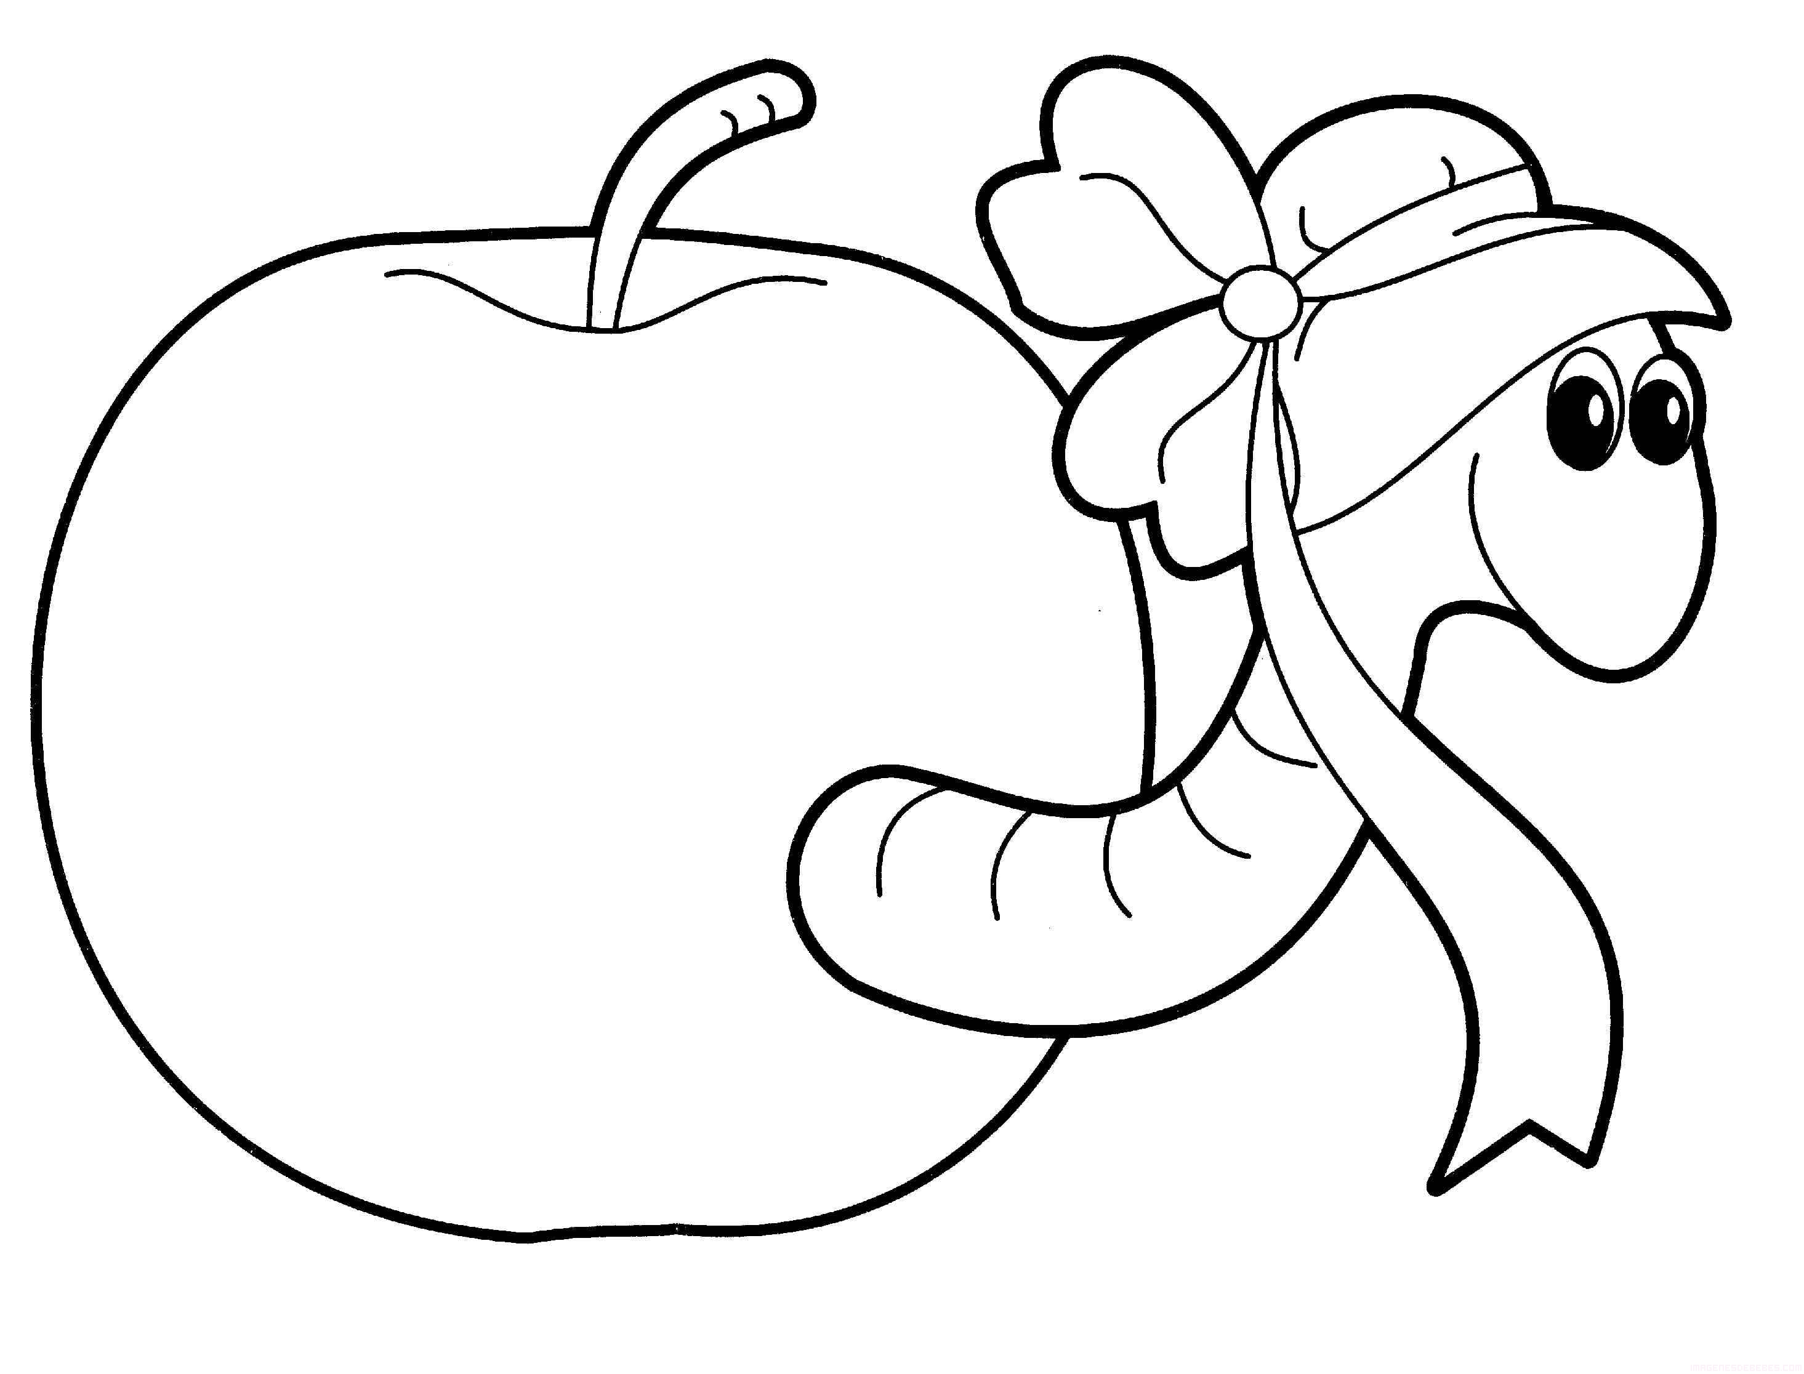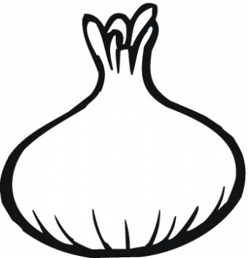 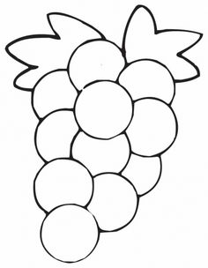

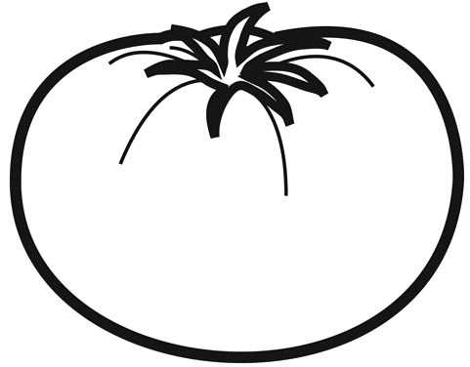 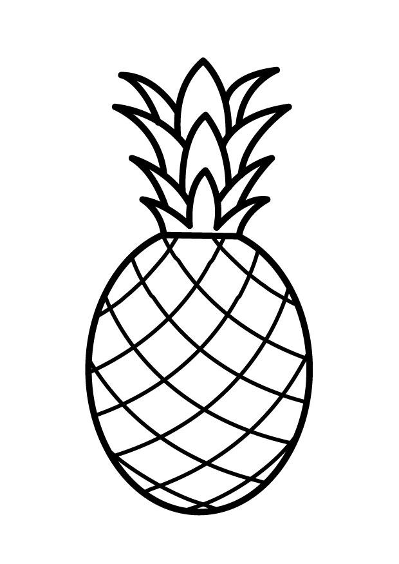 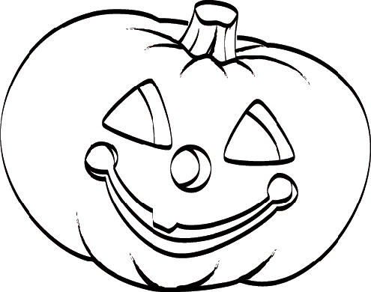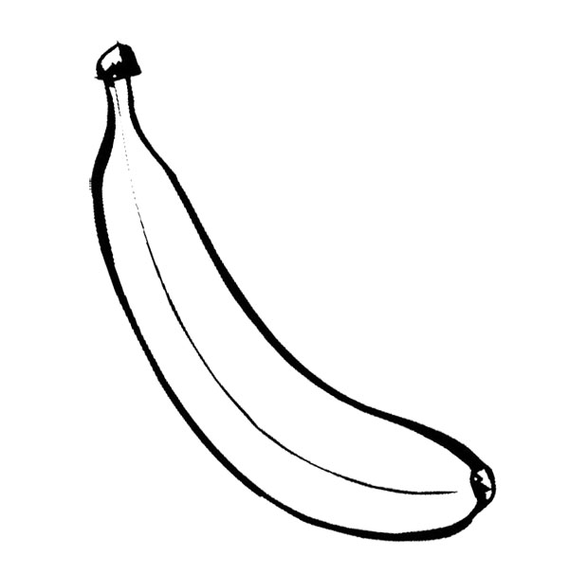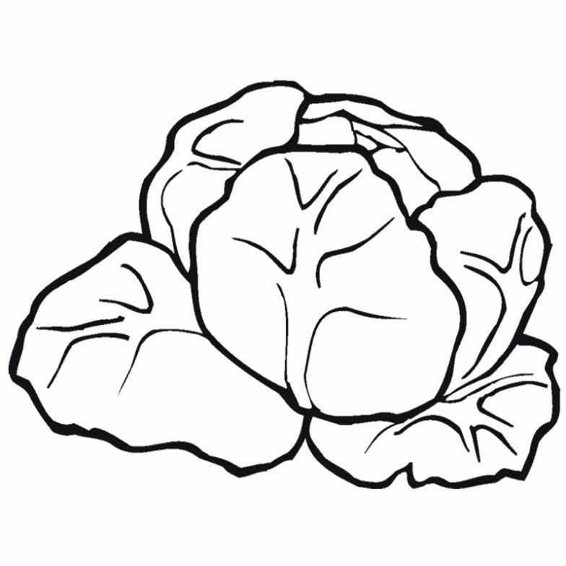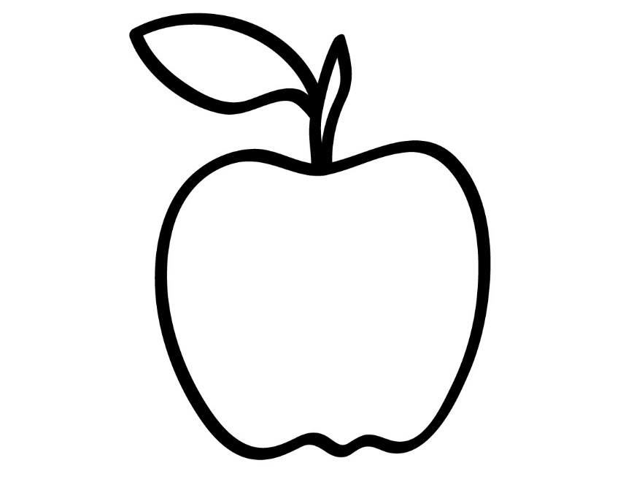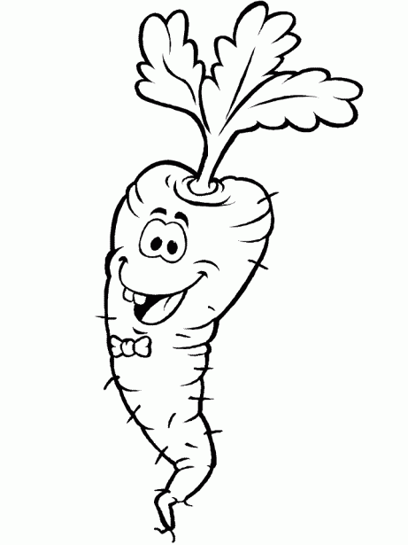 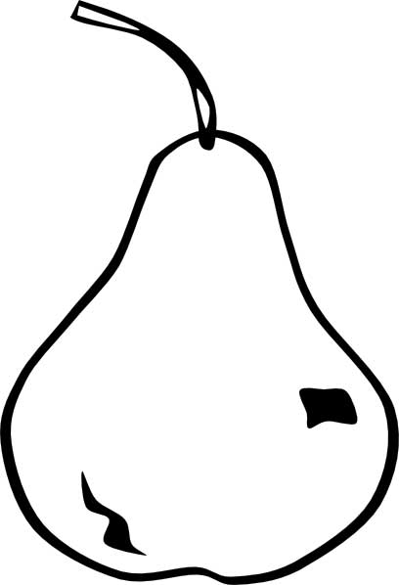 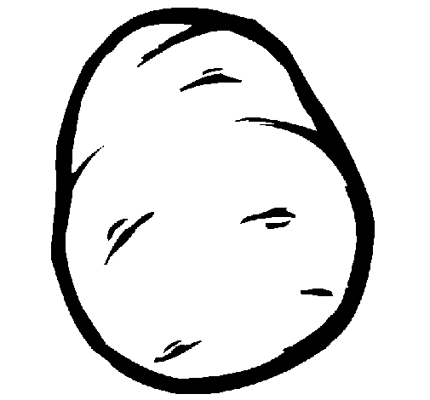

**New Horizon School Aguazul-Casanare**

**Final Test**

**Name**: _____________________________________________________________

**Date**: ______________________________ **Grade**: Kinder

**2. Color the vegetables**

** **

**    **

**4. Circle 15 blenders.**

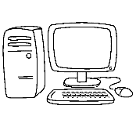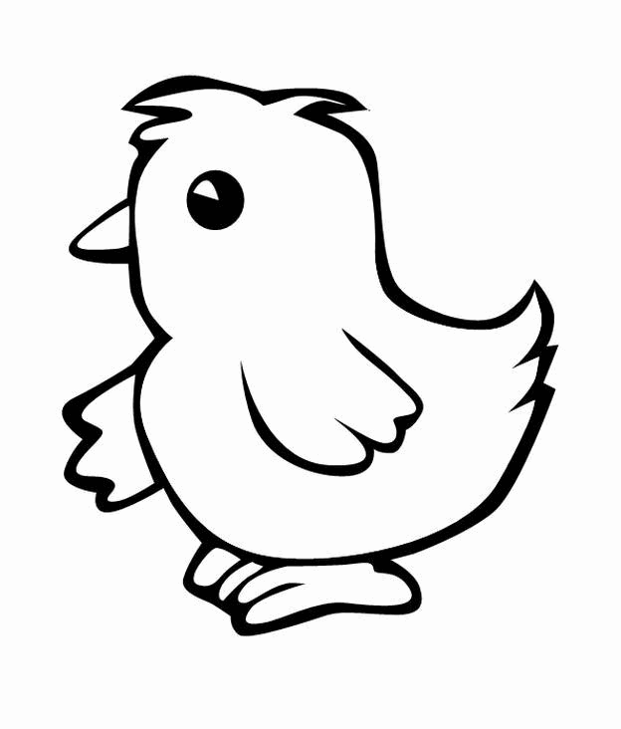

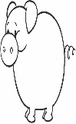

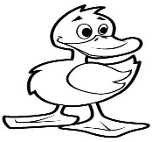

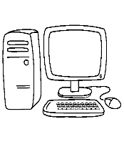



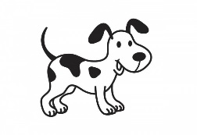

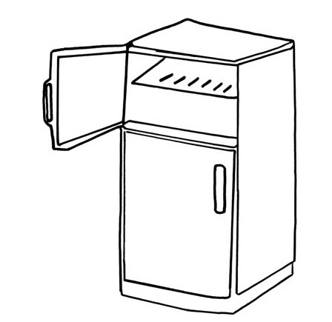

**3. Circle and color 10 refrigerators.**

**4. Circle and color 13 computers**

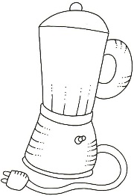

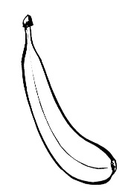

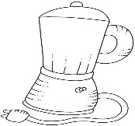

**5. Circle and color 15 blenders.**

**6. Paste ball papers to the lion.**

